**CHAPTER 1**

**ABSTRACT**

This code presents a comprehensive approach to spam classification in SMS messages, utilizing natural language processing (NLP) techniques and machine learning algorithms. The process begins with the exploration and preprocessing of a dataset, involving data cleaning, tokenization, removal of special characters and stop words, and stemming. Exploratory data analysis (EDA) techniques are applied to understand the distribution of the dataset. Various machine learning models including Logistic Regression, Naive Bayes, Support Vector Machines, Random Forest, and K-Nearest Neighbors are implemented and evaluated for their effectiveness in classifying spam and non-spam messages. The optimal model, a Support Vector Machine, is selected based on its superior performance. Additionally, the code includes the analysis of the impact of different K values on the accuracy of the K-Nearest Neighbors model. The final chosen model is saved along with the TF-IDF vectorizer for future use. The study provides valuable insights into the application of NLP and machine learning for text classification tasks, specifically focusing on spam detection in SMS messages.

**CHAPTER 2**

**INTRODUCTION**

In the ever-expanding digital landscape, where communication is paramount, distinguishing between legitimate messages and unsolicited spam is of utmost importance. Welcome to the realm of our Spam Detection Model, a sophisticated solution meticulously designed to combat the onslaught of unwanted messages and safeguard seamless communication.

**Understanding the Problem:**

Spam messages inundate our inboxes, posing threats ranging from phishing schemes to information overload. Recognizing this challenge, we have meticulously crafted a robust machine learning model capable of discerning between 'ham' (legitimate) and 'spam' messages with unparalleled accuracy.

**Our Approach:**

Our journey begins with Data Cleaning, ensuring the dataset is pristine and devoid of redundancies. We delve into Exploratory Data Analysis (EDA), unravelling insights into the characteristics of spam and ham messages. Rigorous Text Preprocessing follows, where we transform raw text into a format suitable for machine learning algorithms. Through meticulous data visualization, including word clouds and frequency analysis, we gain deep insights into the textual data.

**The Heart of the Model:**

At the core of our solution lies a powerful ensemble of machine learning techniques, including Gaussian Naive Bayes, Multinomial Naive Bayes, and Bernoulli Naive Bayes. These algorithms are trained and evaluated meticulously, ensuring the model's robustness and accuracy.

**Empowering Decision-Making:**

Our Spam Detection Model is not just about accurate predictions; it's about empowering users and businesses to make informed decisions swiftly and efficiently. With the model's ability to process and analyze vast amounts of textual data, it stands as a stalwart guardian against unsolicited messages, enabling smoother communication channels and enhancing productivity.

**CHAPTER 3**

**LITERATURE STUDY**

1. **Email Spam Detection Using Machine Learning Algorithms**

**Author:**

1. Nikhil Kumar
2. Sanket Sonowal
3. Nishant

**Inference:**

Creating a fake profile and email account is much easy for the spammers, they pretend like a genuine person in their spam emails, these spammers target those peoples who are not aware about these frauds. So, it is needed to Identify those spam mails which are fraud, this project will identify those spam by using techniques of machine learning, this paper will discuss the machine learning algorithms and apply all these algorithm on our data sets and best algorithm is selected for the email spam detection having best precision and accuracy.

1. **Machine Learning Techniques for Spam Detection in Email and IoT Platforms: Analysis and Research Challenges**

**Author:**

1. Naeem Ahmed 2. Rashid Amin

3. Hamza Aldabbas. 4. Deepika Koundal

5. Bader Alouffi 6. Tariq Shah

**Inference:**

This paper surveys the machine learning techniques used for spam filtering techniques used in email and IoT platforms by classifying them into suitable categories. A comprehensive comparison of these techniques is also made based on accuracy, precision, recall, etc. In the end, comprehensive insights and future research directions are also discussed.

**3.** **An Efficient Spam Detection Technique for IoT Devices Using Machine Learning**

**Author:**

1.David Halbhuber

2. Jakob Fehle

3. Alexander Kalus

**Inference**

In this article they propose the security of the IoT devices by detecting spam using ML. To achieve this objective, Spam Detection in IoT using Machine Learning framework is proposed. In this framework, five ML models are evaluated using various metrics with a large collection of inputs features sets. Each model computes a spam score by considering the refined input features. This score depicts the trustworthiness of IoT device under various parameters. REFIT Smart Home data set is used for the validation of proposed technique. The results obtained proves the effectiveness of the proposed scheme in comparison to the other existing schemes.

1. **Analysis of Optimized Machine Learning and Deep Learning Techniques for Spam Detection**

**Author:**

1. Fahima Hossain
2. Mohammed Nasir Uddin
3. Rajib Kumar Halder

**Inference:**

The proposed model is implemented in both machine learning and deep learning to establish a comparative analysis. Multinomial Naïve Bayes (MNB), Random Forest (RF), K-Nearest Neighbor (KNN), Gradient Boosting (GB) are used to introduce ensemble method in machine learning implementation. Recurrent Neural Network (RNN), Gradient Descent (GD), Artificial Neural Network (ANN) for deep learning implementation. An ensemble method is constructed to combine multiple classifiers' output. The ensemble methods allow producing better prediction accuracy compared to a single classifier. Our proposed model obtained an accuracy of 100%, AUC=100, MSE error = 0 and RMSE error = 0 for machine learning implementation and accuracy of 99%, loss value= 0.0165 for deep learning implementation based on an email spam base dataset collected from the UCI machine learning repository.

1. **Email Spam Detection using Deep Learning Approach**

**Author:**

1. Kingshuk Debnath
2. Nirmalya Kar

The motivation of this research is to build email spam detection models by using machine learning and deep learning techniques so that spam emails can be distinguished from legitimate emails with high accuracy. The Enron email dataset has been used and deep learning models are developed to detect and classify new email spam using LSTM and BERT. NLP approach was applied to analyze and perform data preprocessing of the text of the email. The results are compared to the previous models in email spam detection. The proposed deep learning approach obtained the highest accuracy of 99.14% using BERT, 98.34% using BiLSTM and 97.15% using LSTM. Python is utilized for all implementations.

**CHAPTER 4**

**EXISTING WORK**

Email spam, commonly known as sending unsolicited or promotional emails to a group of recipients, is a common problem. Unsolicited emails are emails for which the recipient has not been explicitly authorized. Over the past decade, spam rates have increased significantly, posing significant challenges for Internet users. Spam is harmful for many reasons:

it consumes storage space, hinders email system efficiency, and wastes recipients' time.

Historically, automated email filtering systems have been the primary means of identifying and managing spam. Nevertheless, contemporary spammers have developed sophisticated techniques to bypass these filters. While in the past, many spam emails could be manually blocked based on their origins or specific email addresses, this method is no longer as effective due to evolving spamming tactics.

To combat this ever-growing problem, the adoption of machine learning approaches for spam detection has gained prominence. These approaches encompass various strategies, including text analysis, white and blacklists of domain names, and community-based techniques. Text analysis, which evaluates the content of email messages, is widely utilized to discern spam from legitimate communications. Solutions can be deployed on both the server side and the client side. The Naive Bayes algorithm is an important option in these processes. However, content-based analysis can be difficult because it can lead to false positives, i.e., legitimate messages being misclassified as spam.

The blacklist approach involves accepting all emails except those from blacklisted domains or email ids. As spammers continuously create new domains, this method becomes less effective. In contrast, whitelisting allows emails to be sent from pre-approved domains or addresses while requiring others to go through a secondary authentication process, ensuring their legitimacy.

Spammers have evolved and now use popular social media tools to target specific user segments, review sites or fan pages, often embedding links Links hidden in text lead to pornographic or fraudulent product websites. These malicious emails share common characteristics, which improves detection by analyzing these patterns.

Artificial intelligence (AI) plays an important role in classifying emails as spam or non-spam. By extracting features from the title, subject, and email content, AI can group messages into appropriate categories. Learning-based classification assumes that spam emails have unique characteristics that distinguish them from legitimate correspondence. However, spam recognition in learning-based models is complicated by factors such as subjectivity, conceptual variation, linguistic variation, processing overhead, and latency in text analysis.

A notable example of a learning-based model is the Extreme Learning Machine (ELM). This modern machine learning model, characterized by a single hidden layer in a feedback neural network, overcomes the problems associated with slow learning and overfitting commonly found in traditional neural networks. ELM has generalizability potential, high robustness, and superior controllability, making it a popular choice in a variety of fields.

In this context, the study explores a series of machine learning algorithms for spam detection, delving into their architecture, advantages and disadvantages. The article also looks at the basic characteristics of spam emails. By conducting a comprehensive assessment of existing techniques and the nature of spam, the study identifies research gaps and presents open research problems as well as future directions to enhance security email and improve spam filtering using machine learning methods.

Various challenges facing current spam filtering models and their implications for the effectiveness of the models are discussed. This study provides an in-depth comparison of machine learning techniques and presents a comprehensive taxonomy of spam detection methods based on machine learning principles. Additionally, this study explores potential directions for future research on spam detection and filtering to improve the accuracy and security of messaging platforms.

**CHAPTER 5**

**PROPOSED WORK**

Machine Learning (ML) plays a pivotal role in spam detection due to its ability to analyze vast amounts of data and identify patterns that can be used to distinguish spam from legitimate content. ML algorithms, such as Naive Bayes, Support Vector Machines (SVMs), and deep learning models, have proven highly effective in automating the process of classifying messages as spam or not. ML-based spam detection systems continuously learn and adapt to evolving spamming techniques, ensuring that users are protected from unwanted and potentially harmful messages.

**Natural Language Processing (NLP):**

* NLP is a field of artificial intelligence (AI) that focuses on the interaction between computers and human language.
* It involves tasks like text analysis, speech recognition, language generation, and sentiment analysis.
* NLP techniques are used to process and understand human language, making it valuable in applications like chatbots, translation services, and text summarization.

**K-Nearest Neighbors (KNN):**

* KNN is a simple machine learning algorithm used for classification and regression tasks.
* In KNN, data points are classified based on the majority class among their k-nearest neighbours in the feature space.
* It's a non-parametric algorithm, meaning it doesn't make assumptions about the underlying data distribution.
* KNN is straightforward to understand and implement but may not perform well on high-dimensional data or when the dataset is imbalanced.

**Naive Bayes:**

* Naive Bayes is a probabilistic classification algorithm based on Bayes' theorem.
* It's called "naive" because it assumes that the features used for classification are conditionally independent, which is often a simplification.
* Naive Bayes is commonly used for text classification tasks, like spam detection and sentiment analysis.
* Despite its simplicity, Naive Bayes can perform surprisingly well in many real-world applications.

**Logistic Regression:**

* Logistic Regression is a statistical model used for binary classification tasks.
* It models the probability that an instance belongs to a particular class using the logistic function.
* Logistic Regression is a linear algorithm, making it interpretable and easy to implement.

**CHAPTER 6**

**RESULTS AND DISCUSSION**

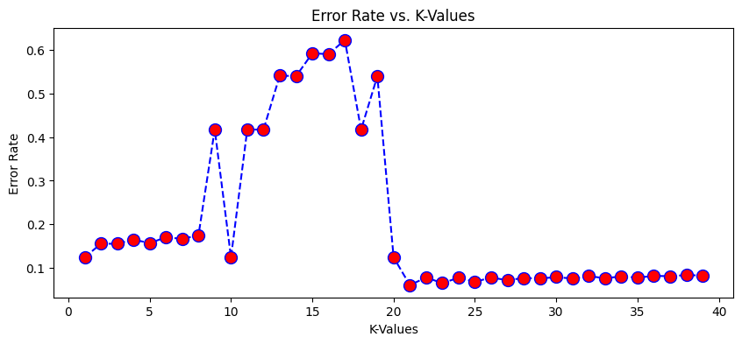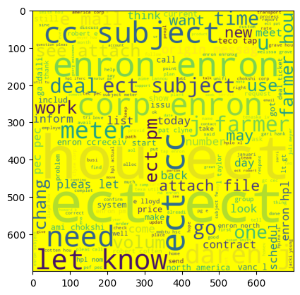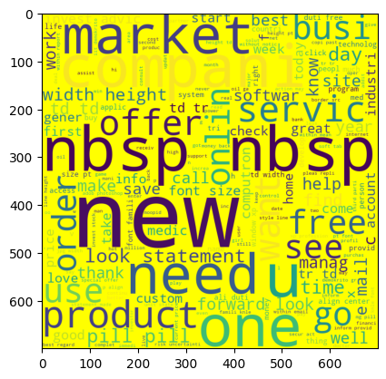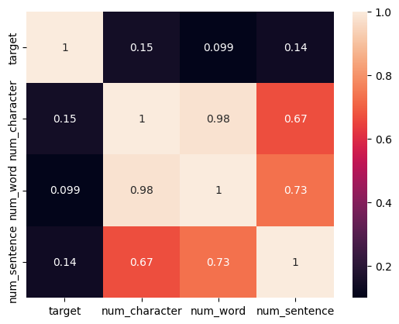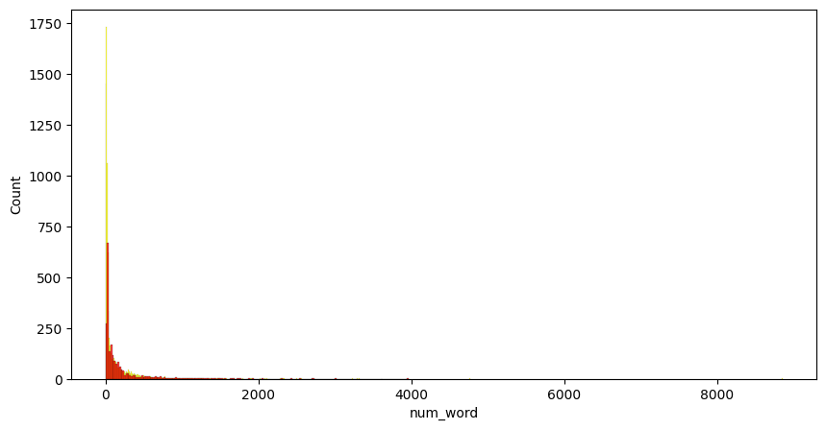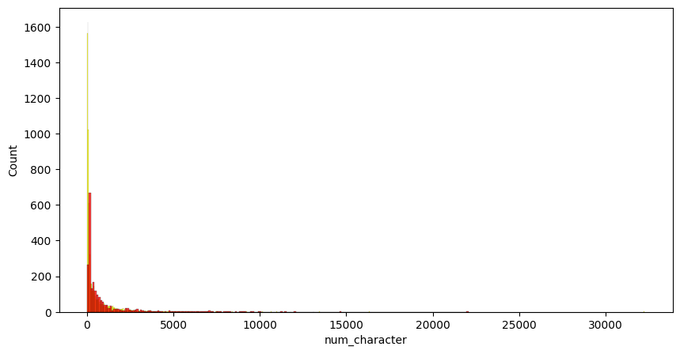

**CHAPTER 7**

**CONCLUSION**

In this comprehensive analysis and implementation of SMS spam classification, several key steps were undertaken to achieve an effective solution. The process began with data loading and exploration, followed by meticulous text preprocessing involving lowercasing, tokenization, special character removal, stop words elimination, and stemming. This preprocessing was crucial to transform raw text data into a format suitable for machine learning algorithms.

Exploratory Data Analysis (EDA) provided valuable insights into the dataset, highlighting differences in character counts, word counts, and sentence structures between spam and ham (non-spam) messages. Visualizations, including histograms and word clouds, were employed to better understand the most common words used in both spam and ham messages.

Several machines learning algorithms, including Logistic Regression, Naive Bayes, Support Vector Machines (SVM), Random Forest, and K-Nearest Neighbors (KNN), were applied and evaluated for their spam classification accuracy. The SVM model emerged as the most accurate, making it the chosen model for the task. The impact of different K values on the KNN model was analyzed, with an optimal value selected for improved accuracy.

The final model was saved for future use, allowing for seamless integration into applications or services requiring real-time SMS spam detection. Additionally, the preprocessing techniques and model selection process outlined in this code serve as a valuable reference for similar text classification tasks.

In summary, this project not only provided an effective spam classification solution but also demonstrated the importance of thorough data preprocessing and model selection in achieving accurate results. The code serves as a robust foundation for further enhancements and applications in the realm of text-based spam detection and classification**.**

**REFERENCES**

[1] Email Spam Detection Using Machine Learning Algorithms, 2020 Second International Conference on Inventive Research in Computing Applications (ICIRCA)

[2] Machine Learning Techniques for Spam Detection in Email and IoT Platforms: Analysis and Research Challenges, Security, Trust, and Privacy in Machine Learning and Internet of Things 2021

[3] An Efficient Spam Detection Technique for IoT Devices Using Machine Learning, IEEE Transactions on Industrial Informatics, Published: 2022

[4] Analysis of Optimized Machine Learning and Deep Learning Techniques for Spam Detection, IOT, Electronics and Mechatronics Conference (IEMTRONICS), IEEE International 2021

[5] Email Spam Detection using Deep Learning Approach, International Conference on Machine Learning, Big Data, Cloud and Parallel Computing (COMITCon) 2022